Princeton Infrared Technologies, Inc. Media Contact: Marlene Moore
9 Deer Park Drive, Suite J-5 Smith Miller Moore
Monmouth Junction, NJ 08852 Phone: 818-708-1704
Contact: Martin Ettenberg Email: Marlene@smithmillermoore.com
Phone: +1 609-917-3380
E-mail: Martin.Ettenberg@princetonirtech.com
Web Site: www.princetonirtech.com
For Immediate Release

New, Affordable USB3.0 SWIR OEM Linescan Camera for
Machine Vision & Spectroscopy

•Princeton Infrared’s affordable OEM SWIR/visible linescan camera will premiere at SPIE’s Photonics West, Moscone Convention Center, Jan. 29 - Feb. 2, 2017 in booth #312.

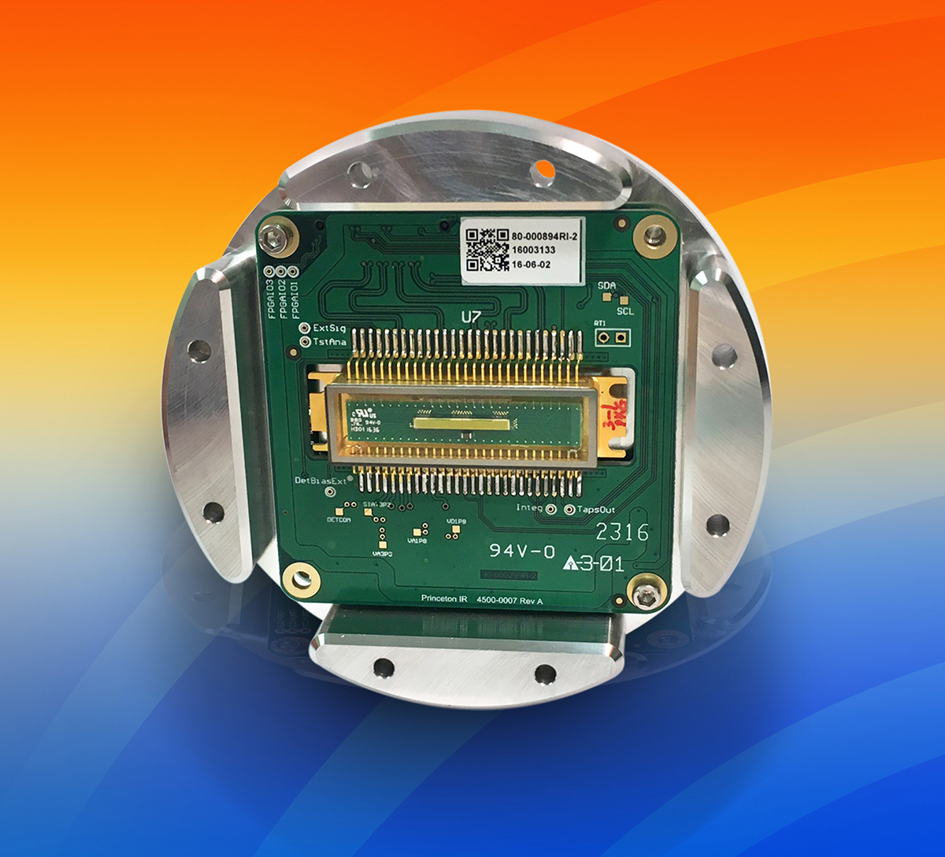
Monmouth Junction, NJ - December 15, 2016 - Princeton Infrared Technologies, Inc. (PIRT) (www.princetonirtech.com), introduces the OEM version of its LineCam12, an affordable, indium gallium arsenide (InGaAs) linescan camera that operates from 0.4 to 1.7 µm in the shortwave infrared (SWIR) and visible spectrum. Compact, with USB3 Vision™ and Camera Link digital outputs, the camera features a 1024 x 1 pixel format with a 12.5 µm pitch; it can be powered by USB3.0 in most applications. This is the only SWIR linescan camera currently available with USB3 Vision. It is also the only USB3 camera that can image SWIR and visible light simultaneously. The new OEM model allows for easy integration into new or existing spectroscopy and machine vision systems.

The advanced SWIR-InGaAs 1024-element linear array can image over 37k lines per second and comes in two models: the LineCam12-12.5-1.7T-OEM with 250 µm tall pixels for spectroscopy, and the LineCam12-12.5-1.7M-OEM with 12.5 µm square pixels for machine vision tasks. The OEM versions can be configured with customized settings to meet customer needs, including high temperature operation at 70 °C or very cold operating temperatures of -40 °C.

Advantages to the new SWIR OEM linescan camera include the low read noise of
<80e- which is a factor of 4x lower than the best in the industry. Combined with varied integration times from 10 µs to >10 s and the 14-bit analog-to-digital conversion (dynamic range >6000:1), the LineCam12 provides excellent versatility. In addition, the incredibly large selection of full wells from 75ke- to 100 Me- with 128 steps of variation, far exceeds any other linear array in the SWIR band. Importantly, there is also on-chip

-more-

optical pixel binning available by command, which allows the user to trade spectral resolution for increased signal levels, as well as faster line rates. Princeton Infrared’s advanced TEC-stabilized camera offers 18 non-uniformity correction (NUC) tables (12 factory-set and 6 user-defined) for additional flexibility.

Martin H. Ettenberg, Ph. D., president of Princeton Infrared Technologies, notes, “I am happy to introduce the newest version of our state-of-the-art SWIR linescan cameras. The OEM model enables us to work with our customers to integrate the camera into their existing system. We can also provide a wide variety of customizations that other manufacturers cannot provide. Utilizing our fabless manufacturing model, we are able to quickly innovate and thus enable numerous new machine vision and spectroscopic applications in the SWIR band at a much lower cost than other SWIR cameras on the market.”

The USB3.0 SWIR OEM LineCam12 is specially designed and optimized for complex and demanding imaging applications, for example in Raman spectroscopy, and in environments where objects are moving quickly (factory lines), such as sorting, detecting moisture, characterizing different plastics, and more. The camera starting price is $9500 in single units. For multiple units or OEM quantities, please contact PIRT for pricing.

To learn more about Princeton Infrared Technologies’ full line of affordable shortwave infrared linear arrays and cameras, please visit booth #312 during SPIE’s Photonics West, Jan. 29 - Feb. 2, 2017 at Moscone Convention Center, San Francisco, or go to: www.princetonirtech.com, or call 1-609-917-3380 for pricing.

Princeton Infrared Technologies, Inc. (PIRT - www.princetonirtech.com) - Specialists in indium gallium arsenide (InGaAs) imaging technology, PIRT focuses on design and manufacture of both shortwave infrared cameras, and one- and two-dimensional imaging arrays. All products are created in the company’s fabless environment under strict testing and quality control guidelines, providing innovative and cost-effective detectors that image in the visible, near- and shortwave-infrared wavelengths. Application areas include spectroscopy for sorting materials, moisture detection, thermal imaging, night vision, and laser imaging for military, industrial, and commercial markets.
# # #

